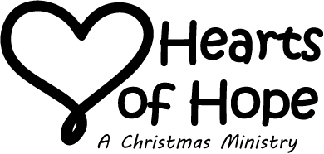
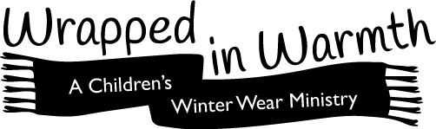

A special gift has been selected and given in your honor. Through that Gift of Hope and Warmth, you have become part of a very special mission.

For the past 30 years, Covenant Community Presbyterian Church has organized a ministry to area families-in-need that includes providing warm winter outerwear and gifts for the children, Christmas dinner fixings and extra food provisions.

This year, we have increased the number of families who receive those items from 30 to 85 – a significant increase. The need in our area is compelling. Those 80 families translate into 238 children which become over 1000 Hearts of Hope and hundreds of boots, jackets, snow pants, gloves and hats!

Prior to Christmas, we have delivered over 200 sets of winter outerwear to our adopted families. We pull from our Care Closet and provide winter jackets, snow pants, boots, hats and gloves to meet the needs and sizes of each child.

In addition to providing winter apparel to our adopted families, we respond to requests from school counselors who identify students who come to school in need of clothing (winter or other).

In Galatians, Paul explains Christianity as Faith lived through Love. This ministry is a living example of that Love. A Gift of Love has been given to a child in need or a monetary donation has been made to this ministry as a tribute to you. We are honored to recognize the positive impact that you have had on the lives of others.

Embracing All. Feeding Spirits. Reflecting Christ ... Changing Lives Forever!
