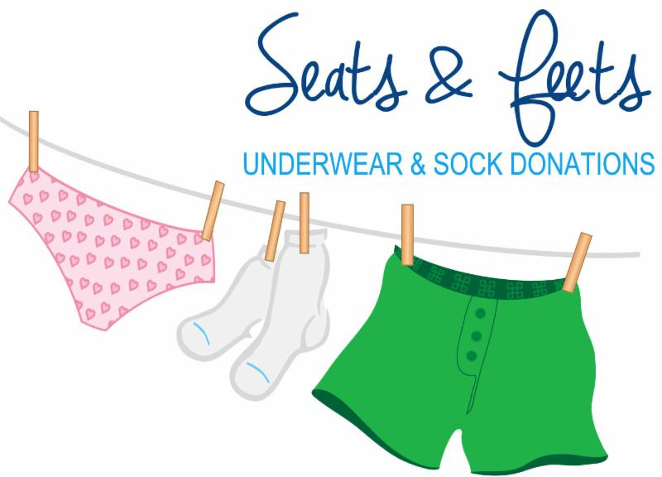

Seats and Feets – Filling a Void, Sharing Hope!
Our Hearts of Hope families and area school counselors have asked for help providing the very basic necessities of socks and underwear. Most of us take for granted our well-stocked socks and underwear drawer, but given the choice between providing food or replacing well-worn socks, food will always be the choice for many area families.
Join us in our Seats and Feet campaign to collect 1000 NEW pairs of socks and underwear to gift to our Hearts of Hope families and fill requests from area school counselors. We need all sizes of each from Youth Small to Adult X-Large.
Ways to Help:
Shop sales and clearance and donate
Redeem reward dollars to purchase socks and underwear
Text Savvy – Start a Go-Fund Me page
Organize a drive at your workplace
Ask your employer to match your donation
Request socks and underwear for birthday gifts
Children’s birthday party – ask guest to bring a donation of socks or underwear in lieu of a gift
Hosting an event – suggest to attendees bring a donation of new socks or underwear
Create a Seats and Feets Scavenger Hunt
Your creative idea
All donations of NEW socks and underwear can be dropped off at:
Covenant Community Presbyterian Church
1806 Weston Ave, Schofield, WI 54476
715) 359-6467
Questions? – Call Sue Thompson at 715-571-2797

